How to integrate hotel lock DLL(SDK) with your PMS?
After you install our software 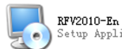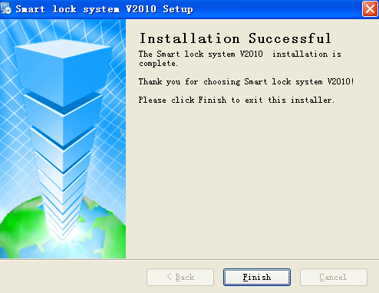 and Then press and choose “Shortcuts” enter the interface 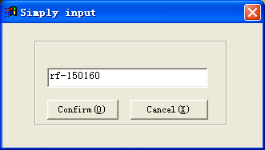
Pls key into Register code: rf-150160 and press the button “OK”.
After register the software by rf-150160 successfully, pls add room number 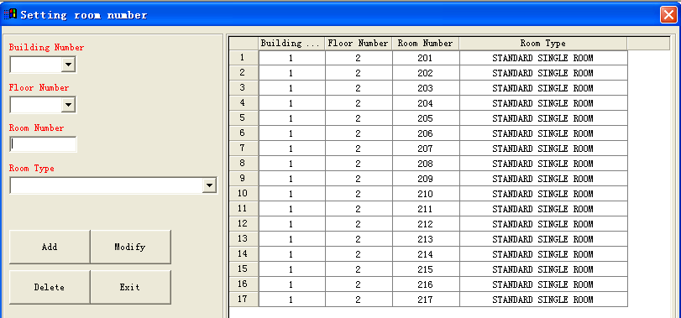 in the software, then you can integrate our lock software DLL(SDK) with your PMS.

